Solid Waste facility issues

Updated 4/24/20

1. **Tom spreadsheet**
   1. Inserts and updates
   2. Possible corrections using UI?
      1. 134-015D(MSWL) – Wrong address for Telfair county: current Address: 713 TELFAIR AVENUE MCRAE GA 31055 - change to 98 landfill ln.

4-21-20: LEMIR, GEOS, FIS all show 98 Landfill Lane

* + 1. 134-009D(SL) -- was this ever Migrated? KS says create own Facility … (Both 134-015D(MSWL) and 134-009D(SL) point to LEMIR 6542. We need to determine how both look presently, then figure out how to split them.

134-015D(MSWL) search returns LEMIR 6542 (Telfair County Landfill)

134-009D(SL) search returns LEMIR 6542 (same facility)

LEMIR 6542 linked to FIS 8095. GEOS shows Facility_RID = 257112 (TELFAIR COUNTY LANDFILL) for FIS 8095.

FIS 8095 links to only LEMIR 6542. LEMIR 6542 has EI’s for Scrap Tire, MSWL (permit 134-015D(MSWL)), GWM, MM; has issuances for 134-015D(MSWL) for MSW/C&D/Industrial, 134-001-GN (Scrap Tire Generator); 134-009D(SL) for MSW/C&D/Industrial

Proposed Correction steps (cannot do in UI):

* Need to split in LEMIR. Review names, permits, detail data in Land Database, determine name for 134-009D(SL) that will differ slightly from 134-015D(MSWL)
* Create insert scripts for LEMIR tables using data for 134-009D(SL)
* Create update script for LEMIR – GOV.SUB_PERMIT to repoint 134-009D(SL) to new facility
* Beverly/Ryan(?)/Mike to reconcile in FIS creating new Master
* Find out who is RO. RO to associate to new FIS MFL ID as well as stay associated with older GEOS 257112.
  + 1. 033-039D(SL) -- has same name as 033-037D(SL) and has added EI of 033-095P(CO) -- name matches -037 needs name changed to Cobb Co - County Farm Dr Ph 2 (SL)- split off composter

033-039D(SL) search returns LEMIR 345958, name is Cobb Co - County Farm Rd #2 Phs 1-2-3 (L), FIS MFL 33878 (name COBB CO - COUNTY FARM RD #2 PHS 1-2-3 (L)), has EI’s for Composting, MSWL, GWM, MM

033-037D(SL) search returns LEMIR 350995, name is Cobb Co - County Farm Rd #2 Phs 1-2-3 (L), no FIS ID, exact name match with 345958. Has EI of only C&D Landfill

* Change name for 033-039D (should be able to do in FIS, GEOS, LEMIR using UI). Except there is no corresponding facility in GEOS!
* Create insert scripts for LEMIR tables using data for 033-095P(CO), can move EI data for Composting to new LEMIR facility
* Beverly/Ryan(?)/Mike to reconcile new LEMIR facility in FIS creating new Master
* Find out who is RO. RO to associate to new FIS MFL ID as well as stay associated with older GEOS for 033-039D(SL)
  + 1. 044-049D(C&D) – wrong address -- Get right address from Program: 044-049 should be East DeKalb Landfill - mailing address is 550 Six Flags Parkway, Mableton, GA 30126

Search LEMIR Prod for 044-049D gives facility ID 10779, FIS ID 6670, GEOS facility 263352 Scales Road Landfill, location address 7253 Scales Road, Lithonia, GA 30058; mailing address is same. This is where we put the permit and environmental interest information when we migrated Solid Waste in 2019.

LEMIR Env Interests are Scrap Tire Dump, SWTF Remediation Site, SW C&D Landfill, GWM, MM. Note from Scrap Tire migration says ‘Migration: This is an abandoned landfill that EPD has responsibility for. Tires are located in the back of the property near the sediment pond.’ Research using Google indicates Mableton address above belongs to Robertson Sanitation, Inc., but Street View shows Republic Services Area Training Center.

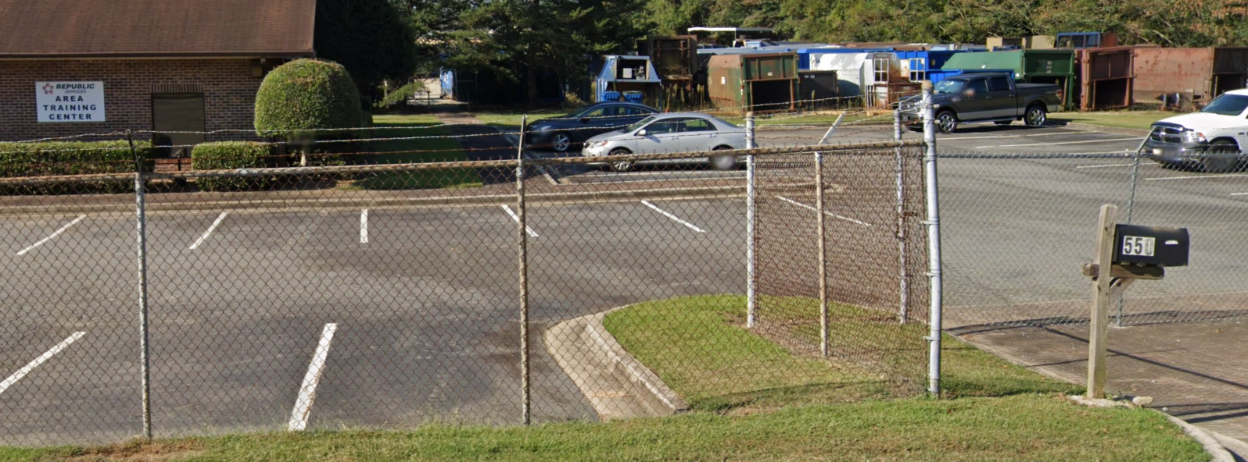

Access Land Database shows address is 5691 South Richland Creek Road, Buford, GA 30518 which is the same as 044-048D(MSWL), and has contact [Sonia.cox@awin.com](mailto:Sonia.cox@awin.com). Which is the right address? Asked program 4/24/20. Response was Six Flags Parkway address is the right one, and name is DeKalb Co.-BFI-East DeKalb Landfill. Changed mailing address and facility name in LEMIR, changes propagated automatically to FIS and GEOS.

* + 1. 025-030D(L) --Marked Inactive (at the facility level, we assume)- made active, reconciled in FIS, but found 3 instances of "Clifton". Active in PCC other references were to proposed expansion area's never built / sold (Savannah Regional Indust LF)

LEMIR search returns 149872 Clifton Equipment Rental Co., 34 Gulfstream Rd, Garden City, GA 31418, FIS 34289, GEOS 262677

What needs to be done, anything?

1. **Beverly requests**
2. 4-21-20: Inland Rome Turner Bend: The facility address is causing the problems at this site. Submittal number is 476968. Permit No. 057-017D(L)(I)

Beverly to Martha Carr [MCarr@geosyntec.com](mailto:MCarr@geosyntec.com) 4/21/20 09:41: In our old database we have 600 Mays Bridge listed. However, there are 2 additional notes.

1. 218 Mays Bridge Rd
2. Address was updated from MAYES BRDG RD 1 MI S SR 20

I don’t know if the 600 Mays Bridge is the updated address or if it was the 218.  Additionally, we have Russell Foulke listed as the site contact. His address is listed as 238 Mays Bridge.

The reason why the addresses are relevant is that this facility was associated to an existing facility at 216 Mays Bridge in GEOS. You have stated before that you have 238 mays bridge on file for this site.

Does this facility need to be associated to a scrap tire, asbestos, ust or PBR-057-26OSP at 238 mays bridge rd? If it is not known, perhaps this facility should be split.

Even if the RO submits the submittal, we can have the developers push it to the correct facility-once we know which one that is.

Beverly to Mike Heaphy 4/21/20 1:42PM:

**From:** Tipton, Beverly <[beverly.tipton@dnr.ga.gov](mailto:beverly.tipton@dnr.ga.gov)>   
**Sent:** Tuesday, April 21, 2020 1:42 PM  
**To:** Heaphy, Michael <[michael.heaphy@dnr.ga.gov](mailto:michael.heaphy@dnr.ga.gov)>  
**Cc:** Stevens, Keith <[Keith.Stevens@dnr.ga.gov](mailto:Keith.Stevens@dnr.ga.gov)>; McManus, Steve <[Steve.McManus@dnr.ga.gov](mailto:Steve.McManus@dnr.ga.gov)>; Sayer, John <[john.sayer@dnr.ga.gov](mailto:john.sayer@dnr.ga.gov)>  
**Subject:** RE: City of LaGrange GEOS Updates

Mike,

To give some more information on the non-city of Lagrange issue from earlier:

A private industrial landfill under LEMIR facility 141520 with permit number 057-017D(LI) is not correctly associated. We had multiple addresses in the SW database for this facility. The Consultant confirmed it should be 238 Mays Bridge and the 141520 facility is associated with 216 Mays Bridge. Should this facility be split and either made a new facility or add to an existing 238 mays bridge facility? The RO will need to submit a minor mod to officially change the address, however they wouldn’t be able to submit the mod until this is fixed.

See screenshots below:

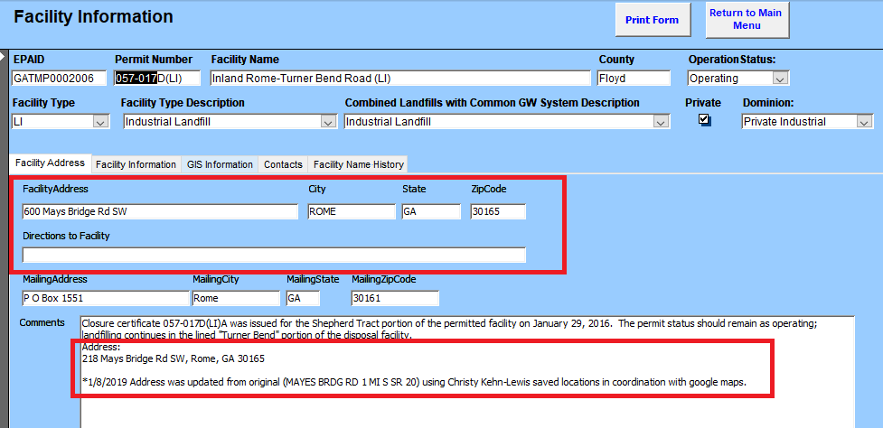

The way the contact address is added, I’m uncertain if that address was original.

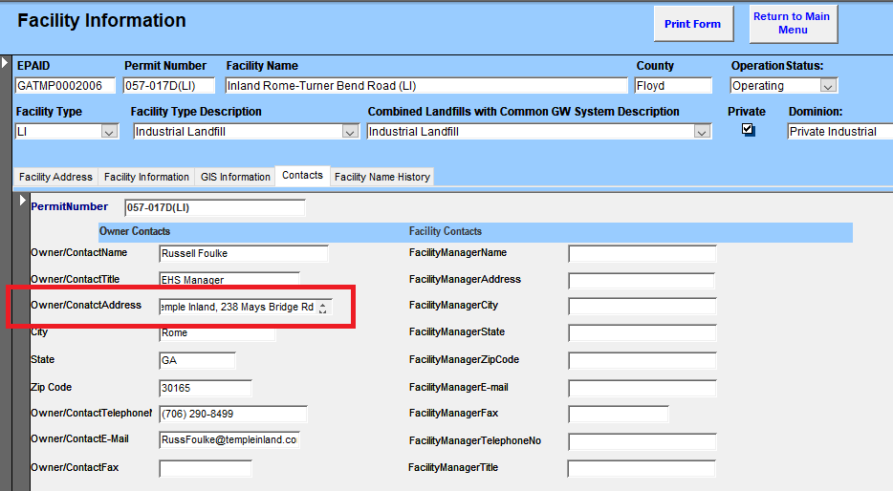

Update 4/22/20:

Martha Carr at Geosyntec in NC who is consulting geologist/preparer for a number of Solid Waste sites emailed in a thread about City of LaGrange Landfill that the RO Laura Connor for International Paper had submitted a Methane Monitoring Report 4/21/20 (submittal 476968 – same as the one noted at the start of this section for Inland Rome Turner Bend landfill. That submission was made to GEOS 603 (INTERNATIONAL PAPER CO. (ROME LINERBOARD MILL)), FIS 34246, LEMIR 329696. Appears relevant to this analysis.

1. Placeholder: Telfair County Landfill – LEMIR 257112
2. Placeholder: BASF Corporation – McIntyre, GA 31054 - BASF McIntyre Landfill – FIS 31916,

permit 158-016D(L)(I)